**Introduction**

This guide explains how teachers in Direct Login & Manual Rostering and Single Sign-On (SSO) and Manual Rostering districts perform the following tasks for programs accessed from the McGraw-Hill ConnectED website.

* Create a Teacher Account
* Redeem Content
* Create Student Accounts
* Create a Class
* Add Students to a Class
* Assign Content to Students

If you are new to ConnectED, we suggest completing each process in the recommended order for the most efficient set-up possible.

Create a Teacher Account

1. Go to [my.mheducation.com](https://my.mheducation.com).
2. Select the **Create teacher account** button.

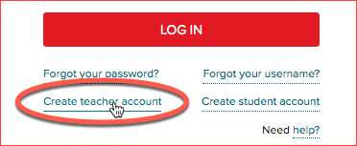

1. Complete the following required fields:
   * **Registration Code**
   * **School Name**
   * **School Email Address**

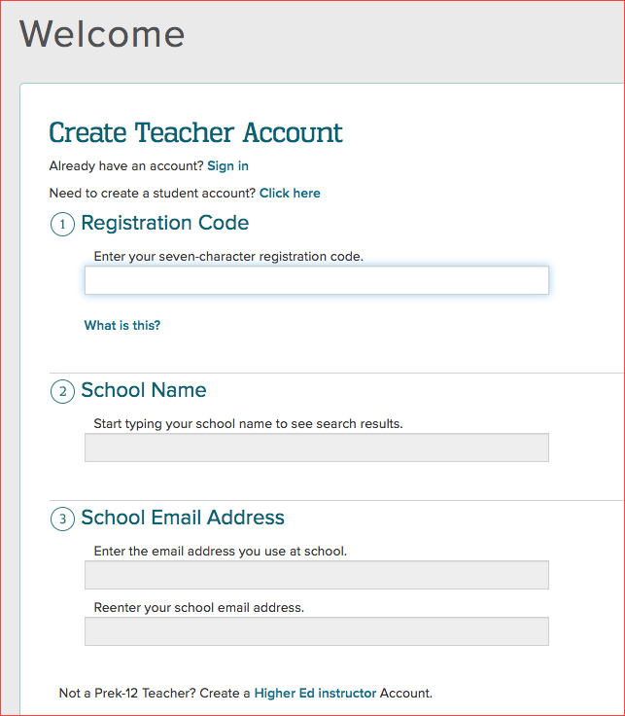

* If you do not have a registration code you will want to speak with your Organization Administrator or call, email, or chat Digital Technical Support at <https://mhedu.force.com/DTS/s/>.

1. Select the **Create Account** button.
2. Complete the required fields of the **Personal Information** section.

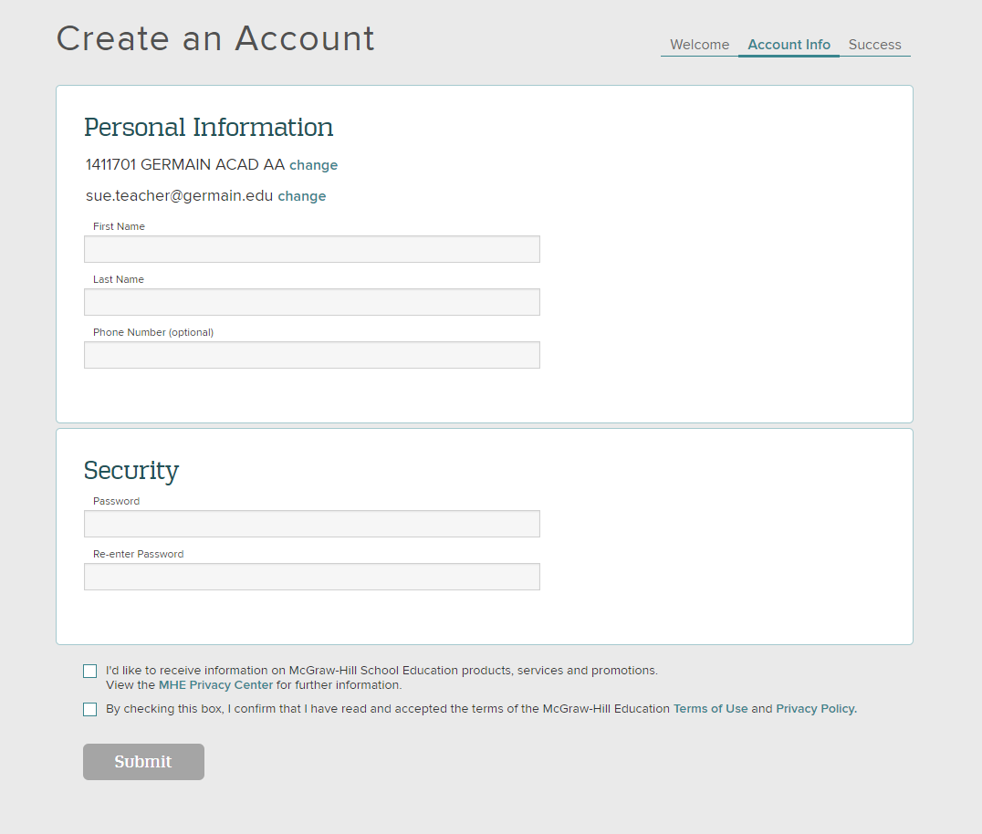

1. Create a password.
2. Select the **Submit** button.

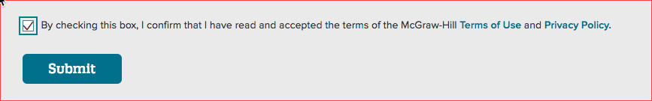

Redeem Content

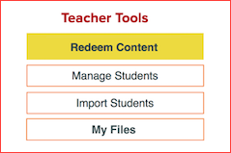

1. On your My ConnectED programs page, select the **Redeem Content** button on the right.
2. Enter your **Master Code** in the provided fields or redeem content from the Library. Learn more: [How to Use the ConnectED Library](https://mhedu.force.com/DTS/s/article/How-to-use-the-ConnectED-Library).  
     
   **Note:** If you do not have a master code, please contact an Organization Administrator to obtain one. If you serve dual roles as a teacher and an administrator, please see [this help article](https://mhedu.force.com/DTS/s/article/ConnectED-How-do-I-locate-the-Master-Codes?dc=) for instructions on how to locate master codes in your administrator account.
3. Select **Next**.
4. If the book is a Teacher Edition, click the **Add Content** button and proceed to Step 6.
5. If the book is a Student Edition, select an **End Date**. The chosen date should correspond to the last day of your school year or semester.  
     
   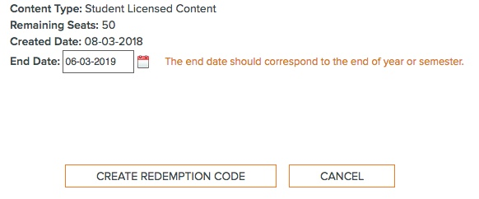
6. Select **Create Redemption Code**. This will create a Redemption Code so your students are able to gain access to the content.
7. Select **OK**.

Create Student Accounts

**Please check with your Organization Administrator before creating student accounts, as they already may have uploaded the students at the school or district level. If you have been instructed to upload your own students, please follow the steps below.** Log in to your account on ConnectED.

1. Select the **Import Students** button found on the right side of the page.



1. Select **Download Student Template** to download a pre-formatted copy of the student template. If prompted, save the file to the location of your choosing.
2. Complete the following fields on the spreadsheet.

**All of the column headings must appear in the spreadsheet, but only columns marked “(required)” are mandatory for completion of this process.**   
  
**Please do not delete any of the columns from the spreadsheet or change the column titles. Changing this information will render the template invalid. The acceptable values for each field are as follows:**

1. **Last Name** (required): 1–50 characters. Only letters, spaces, apostrophes and hyphens are allowed.
2. **First Name** (required): 1–50 characters. Only letters, spaces, apostrophes and hyphens are allowed.

* The **First** and **Last Name** columns must contain 3 characters combined. For example, “Li, Y” is acceptable, but “L, Y” is not.

1. **Middle Initial:** (optional) One letter
2. **Gender** (optional): M or F
3. **Grade Level** (recommended): One of the following: PK, K, 1, 2, 3, 4, 5, 6, 7, 8, 9, 10,11, 12, NA
4. **Username** (optional): If using a customized username it must be unique to the McGraw-Hill Education's global database, not just your account. 3-20 Characters, must contain both letters and numbers, can contain the @ symbol but cannot use any other characters. Usernames are not case sensitive.

* You may also leave this field blank, and the system will auto-generate usernames.

1. **Password** (recommended): Passwords must be between 6-16 characters containing at least 1 letter and 1 number (examples: password1, a12345). Passwords are case sensitive. You may also leave this field blank, and the system will generate passwords.
2. **Redemption Code** (recommended): Multiple Redemption Codes can be used in each template, but only one code can be specified per student. Codes can be entered with or without dashes.

* If you leave this field blank, teachers will have to assign the content to their students manually.

**For a student who will have multiple books i.e. Science, History, Math (meaning they will have multiple redemption codes), leave this field blank. Their teachers can assign their content after those students have been uploaded.**  
  
**For a student who will have only one book, you may enter the redemption code so this upload will both create their student account and load their account with the needed book.**

1. Once you have completed adding student information, save the completed file to a familiar location on your computer.
2. Select the account to which you wish to add the students from the **Account** drop-down menu.

* If you do not see this drop-down menu, please proceed to the next step.

1. Select the **Browse** button and select the completed copy of the template from your computer.
2. Select **Check File for Errors**. The systems will now check your file for any errors. If an error appears, you will be prompted to view the invalid data and correct the spreadsheet.

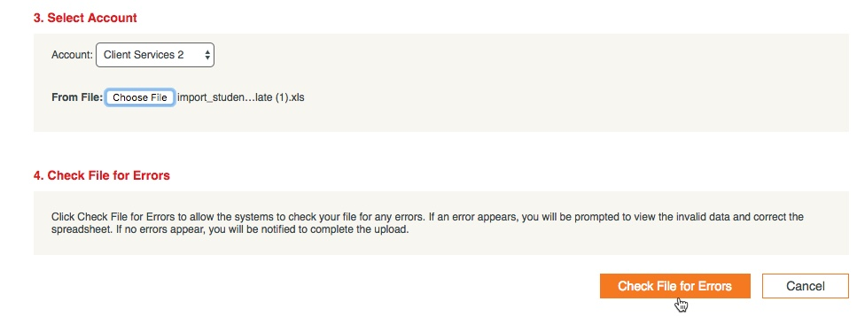

* These changes will need to be made locally, and a new, corrected copy of the spreadsheet will need to be uploaded (see step 2). If no errors appear, you will be notified to complete the upload.

Create a Class

1. When you are in the program, select **Class Management** from the Navigation Menu.  
     
   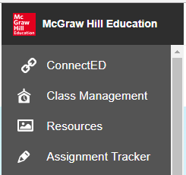

* Please note that the page name may be called Manage & Assign, depending on your program.

1. On the **Class Management** (or **Manage & Assign**) page, select the **Create Class** button at the top of the screen.



1. On the Create Class pop-up, enter a **Class Name**
2. Select a **Grade Level** from the drop-down list.

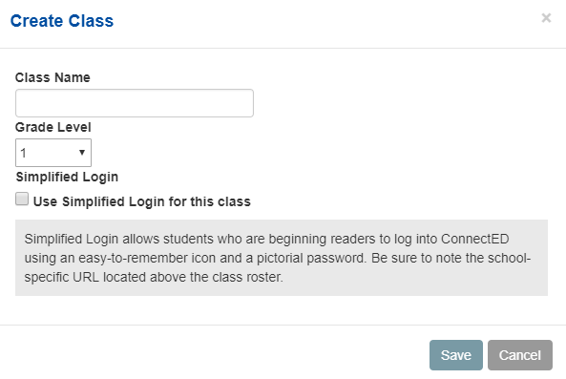

1. Select the **Use Simplified Login** for this class check box for younger classes. This will generate an icons for younger readers to identify the class and their accounts.
2. Select the **Save** button to create your class.   
     
   The new class now appears on your **Class Management** (or **Manage & Assign**) page.

Add Students to a Class

You have two options for adding students to a class.

Locate Class Code

If you have students with existing accounts (either a ConnectED account or a my.mheducation.com account), you have the option to distribute a class code which will allow students to enroll themselves in your class. To locate the class code for a ConnectED program:

1. Launch the teacher edition of the program.
2. Select **Class Management** or **Manage & Assign** (option depends on program) from the main menu.
3. Select **View Class Code** at the top of your student roster.   
     
   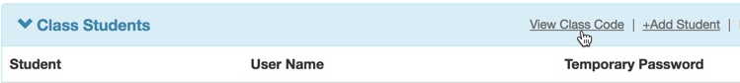

The 8-digit alphanumeric class code will display in the pop-up along with instructions for using the code.  
  
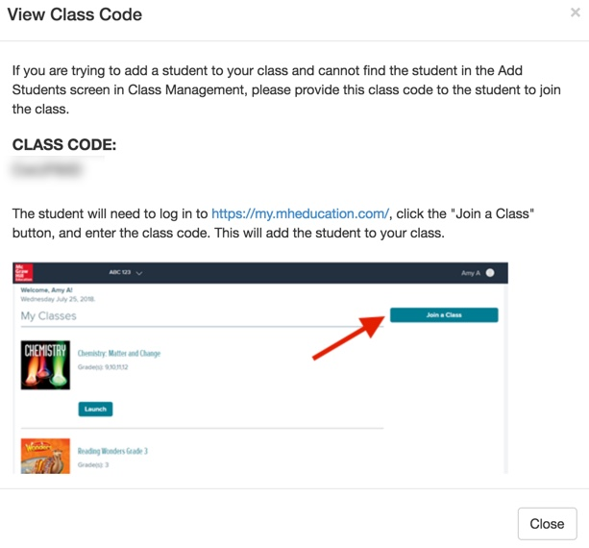

You may have some students who have already received a login from another teacher or an administrator. They can also use this code to join your class. For student instructions on how to use this code to enroll in a class, please see this help article: [Join a Class](https://mhedu.force.com/DTS/s/article/My-mheducation-com-Join-a-Class?dc=Getting_Started_Student)



Enroll Students

If your students are unable to enroll using the class code, you can enroll them directly from your teacher account.

* 1. Select **Manage & Assign** or **Class Management** from the main menu (option depends on program).
  2. Select **My Classes**.
  3. Select **Add Students** at the bottom right.  
       
     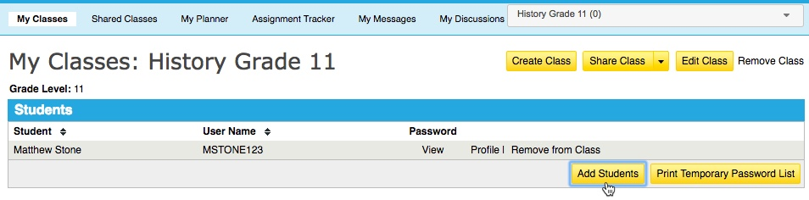
  4. Enter the name or ConnectED username of the student you wish to add and click the **Search** button.
  5. Select the check box next to the student’s name.
  6. Select the **Save** button to add the selected student(s) to your class.  
       
     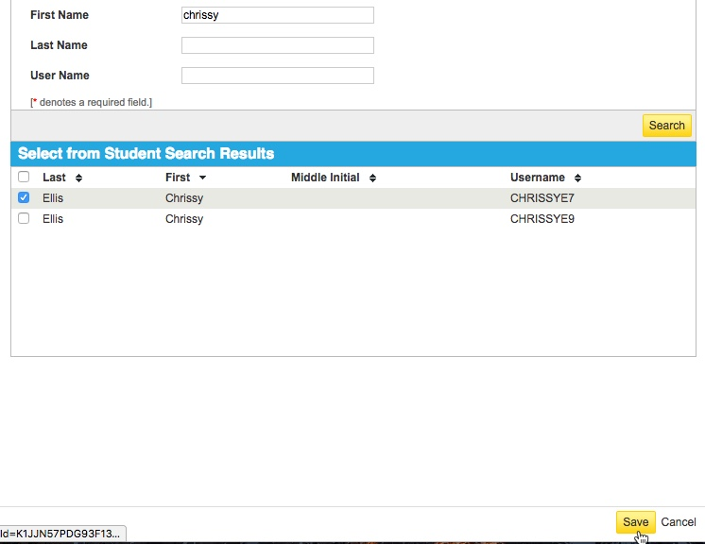

**Enroll Students**

If your students have not yet received their login, or the class code method of enrollment does not work for them, you can enroll them directly from your teacher account.

1. To add students to the current class, select the **Add Students** button.

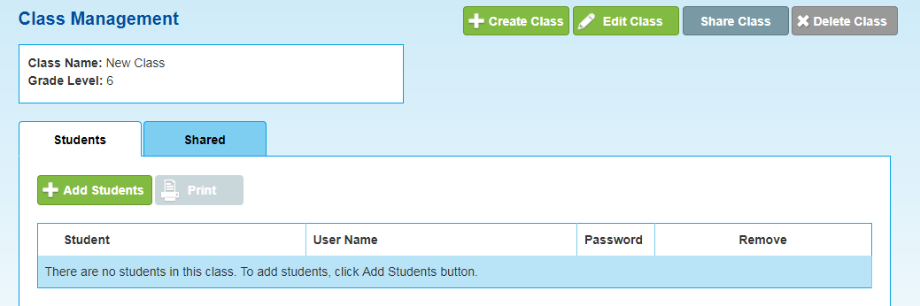

1. You will first search for students to add to your new class.

* You can select students from an existing class, by specific content, by grade level.
* You can also enter a specific student’s name.

1. Select the **Search** button.

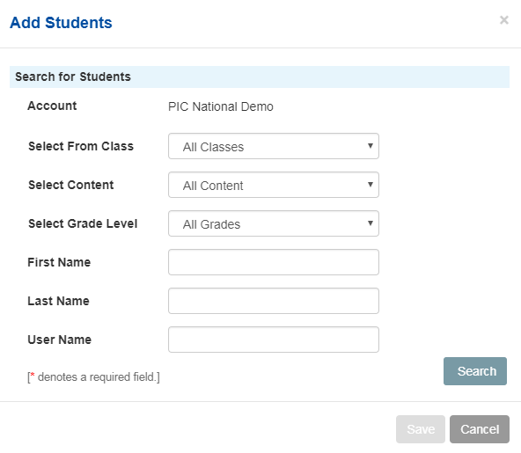

1. From the **Student Search Results**, select students for your class by selecting the check box next to each student’s name.
2. Select the check box at the top of the list to select all the students in the results.
3. Click the **Save** button to save the selected students to the class.

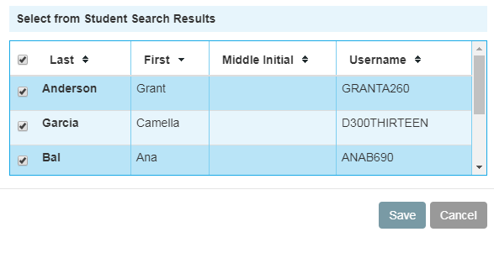

Assign Content to Students

This step is not required if students have already redeemed a code for the content.

* If they’re not sure if they’ve already redeemed their code, they can simply log in to their student account to see if the content is listed under **My Classes**.

1. From **My ConnectED programs**, locate the Student Edition you wish to assign.
2. Select **Assign Content**.  
     
   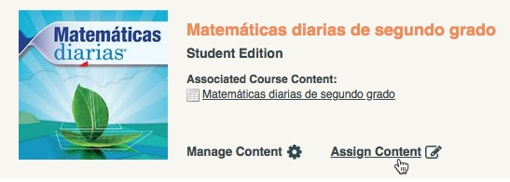
3. Select the check box to the left of the book icon.
4. Select the **Next** button.  
     
   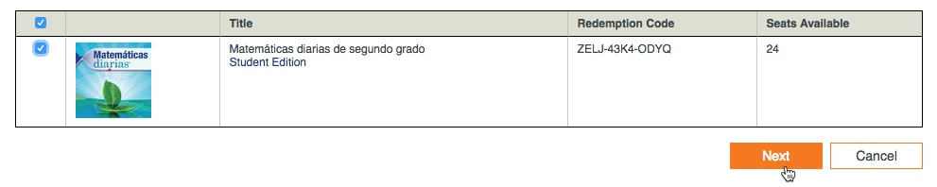
5. Use the **Class Name**, **Teaching Level**, or **Student Name** to locate the student(s) that need access to the selected content.
6. Select the **Search** button.
7. Once you have located the correct student(s), check the box to the left of their name(s).
8. Select the **Next** button.
9. On the next screen, confirm that you selected the correct students, and select **Assign**.

Your ConnectED set-up is now complete.